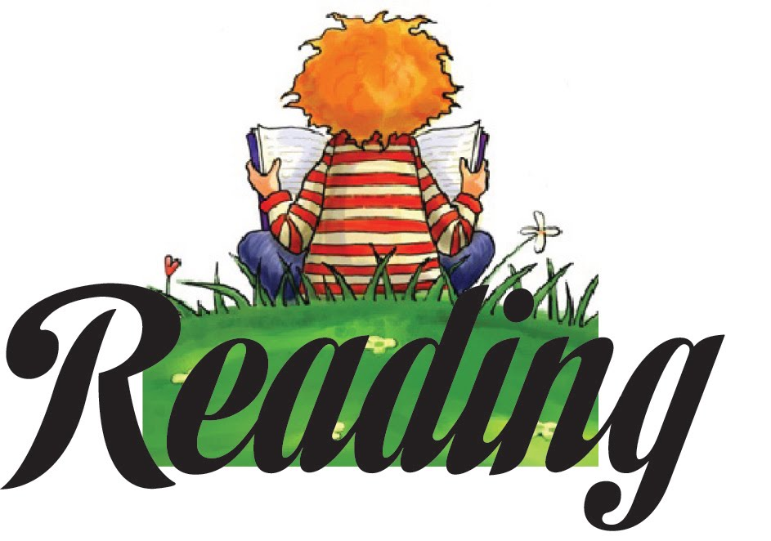
Holy Spirit School 2015
Summer Reading List

Reading is fundamental to learning. It increases your vocabulary, enriches your mind, and stretches your imagination. Recognizing these factors, Holy Spirit School requires all students entering grades K-8 to complete a summer reading program. In addition to these required texts, we have included a list of optional selections and recommended read-aloud books, which we also encourage you to read. The books are available in paperback at local bookstores, libraries, and on-line. This brochure is also located on the School’s website at www.holyspiritflames.org under the “Student Resource” tab at the top of the front page.

ENTERING KINDERGARTEN

Help your child begin the journey into the world of reading with the most enduring classics of children’s literature: nursery rhymes. The rhythm and rhyme of these verses give children important early experience with literature and reading through listening, echo reading, and retelling. Your child should be able to recite the Mother Goose Rhymes at the beginning of the school year.

Read to your child DAILY. When you finish a book ask your child what he/she liked about the book. Encourage discussion about the book with your child. He/she should begin to express answers in complete sentences. Avoid questions with yes/no answers. Rather, ask questions such as ‘why did……go out to the tree?’ and ‘what was your favorite part of the story?’ Help your child develop critical thinking skills by discussing possible endings to a story. Children enjoy imagining what they would have done if they were the main character of a story.

Required reading for Kindergarten:

A Ball for Daisy by Chris Raschka
Pancakes for Breakfast by Tomie dePaola

These two books are NO WORD books. Your child can tell you the story using the pictures many times through the summer.

Suggested authors for reading to your child:

Leo Lionni Eric Carle
Dr. Seuss Tomie dePaola
Ezra Jack Keats Maurice Dendak
Mercer Mayer Arnold Lobel
Barnard Waber Robert Kraus
Margaret Wise Brown Syd Hoff
Bill Martin Emily Arnold McCully
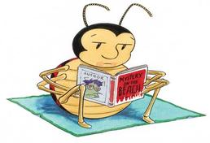

ENTERING 1ST GRADE

Students are encouraged to read daily with adults over the summer. Engage your child in the story by asking questions. Students may also pair read at this stage, where you read a page, then your child reads a page.

Some suggested authors who we will examine during the school year are:

Mo Willems Marla Frazee
Marc Brown Gail Gibbons
Audrey and Don Wood Tomie DePaola
Jan Brett Steven Kellogg
Dr. Seuss Eric Carle
David Shannon Kevin Henkes
Robert Munsch David Ezra Stein
Amy Krouse Rosenthal

On September 4th your child will turn in a list of at least ten books they read over the summer. After turning in the list your child will select their favorite book they read over the summer to do a book report on.
We also strongly encourage journaling over the summer. It can start as just drawing and then develop into a sentence and a picture. It can be about their day or anything from their imagination!

ENTERING 2ND GRADE

Please choose three books from these series:

Mary Pope Osbourne: Magic Treehouse
Peggy Parish: Amelia Bedelia
Barbara Park: Junie B. Jones

On September 8th the students will be asked to bring in a list of the books they have read over the summer.

Other suggested series and authors:

Elisabetter Dami: Geronimo Stilton
Ron Roy: A to Z Mysteries
Marc Brown: Arthur Chapter Books

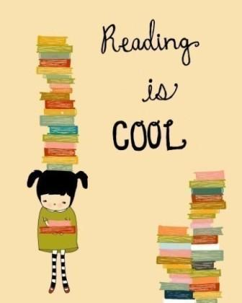

ENTERING 3RD GRADE

REQUIRED:
Clyde Robert Bulla: The Chalk Box Kid (Lexile 270)

Please choose two others from this list:
Donald Sobol: Encyclopedia Brown, Boy Detective Series (Lexile 500-700)
Mary Pope Osbourne: Magic Tree House Series (Choose only 1 from this series) (Lexile 300-600)
Gertrude Chandler: Boxcar Children Series (Choose only 1 from this series) (Lexile 500-700)
Tomie DePaola: 26 Fairmont Ave Series (Lexile 600-700)
Marjorie Sharmat: Nate the Great Series (Lexile 100-400)
Betty Birney: The World According to Humphrey (Lexile 670)
Ron Roy: A-Z Mysteries or Calendar Mysteries Series (Lexile 350-600)
Megan McDonald: Judy Moody Series (Lexile 390-500)
Beverly Cleary; Any story (Lexile 500-730)

After reading two of the books from the student’s choice list, the students should create a poster based on one of their books, and a bookmark based on the other reading choice. These two projects are due on Tuesday, September 8, 2015.

1. Poster: Poster should be no larger than 14” X 24” and must include the title of the book, the author, a short summary of the story (no more than a paragraph), and an illustration which should include characters and the setting.

2. Bookmark: The bookmark must include the title and author of the book and the student’s opinion of the book. Would the child recommend the book to a friend? Write a two or three sentence explanation of why or why not.

Due date: Tuesday, September 8, 2015.
Please also read the Story of Creation in a Children’s Bible.

SUGGESTED READ ALOUD BOOKS FOR 3RD GRADERS
.
Laura Ingalls Wilder: Little House Series
Jack Prelutsky: any book
Shel Silverstein: any book
Phyllis Naylor: Shiloh
Roald Dahl: James and the Giant Peach
E.B. White: Stuart Little or Charlotte’s Web
Kate DiCamillo: The Miraculous Journey of Edward Tulane

ENTERING 4TH GRADE

REQUIRED: Judy Blume: Tales of a Fourth Grade Nothing (470L)

This book will be discussed the first week of school and there will be a test.

Please choose two books from the following list and then choose one project to complete for each book chosen.

Robert Lawson: Ben and Me (1010L)
Richard Atwater: Mr. Popper’s Penguins (910L)
Eth Clifford: Help! I’m a Prisoner in the Library (630L)
Barbara Cohen: Thank you, Jackie Robinson (730L)
Beverly Cleary: Beezus and Ramona (780L)
George Sheldon: A Cricket in Times Square (780L)

Projects to choose from:

1. Make a book jacket using construction paper. Write a summary of the story for the inside flap of your book jacket.

2. Make a giant postcard about a book. Use construction paper. On one side, write the title and author of the book and draw a large illustration. On the other side write a letter to the author telling what you liked about the book.

3. Make a series of three pictures to show an event that happened in the beginning, middle and end of the story. Label each picture with a one or two sentence description.

4. Make three bookmarks about the book. Show a main character, an important scene and the main idea of the book. Label each picture with one or two sentences.

5. Draw an outline of a hand. Label the thumb with the title of the book, one finger with the author, on the last three fingers write a sentence that describes an event from the beginning, middle, and end of the book.
Projects will be due September 11th.

ENTERING 5TH GRADE

The fifth grade summer reading list is filled with many exciting stories from all types of
genres: fantasy, realistic fiction, adventure, historical fiction and biography.

REQUIRED:
Megan Blakemore: The Water Castle (690L)
This book will be discussed the first week of school and there will be a test.

Please choose one from the following list:
Christina Lamb & Malala Yousafzai: I Am Malala (Young Readers Edition) (830L)
Stuart Gibbs: Spy School (770L)
Natalie Babbett: Tuck Everlalsting (770L)
Gordan Korman: Ungifted (730L)
Deborah Wiles: Countdown (800L)
Ivy Ruckman: Night of the Twisters (790L)
Elizabeth Levy: My Life as a Fifth Grade Comedian (520L)
Patricia Reilly Giff: Nory Ryan’s Song (600L)
Gary Paulson: The River (960L)

A Reading Journal Entry should be done for The Water Castle and one of your chosen books. The journal entry should be typed and each entry on a separate page. The Journal Entries are due September 11th.

Format:
Student’s name Date
Title of Book Author
Setting of the story (time period and geographic location (at least 1-2 sentences)
Favorite Character and 2 reasons why (at least 2 sentences)
Favorite part of book and 3 reasons why (at least 3 sentences)
Things the student would change about the book and 2 reasons why (at least 2 sentences)
Character the student would want to have as a friend and 3 reasons why (3 sentences)

Read Matthew 3:1-17 in the Bible. Write a summary of the story in your own words.
Then write a paragraph about your own Baptism with your parents help for information.
Include when and where you Baptism took place, the name of your Godparents, and the
name of the Priest who performed the baptism.

This should be typed. Due September 11th.

ENTERING 6TH GRADE

Required:

Mildred D. Taylor: Roll of Thunder, Hear My Cry (920L)

This book will be discussed the first week of school and there will be a test.

Cynthia Lord: Rules (780L)

Please write an interview book report on this book. It is due September 11th.

Please type your book report.

Interview book report: Pretend you are a reporter and you are interviewing one of the main characters. Begin by writing a paragraph describing the character. Write ten questions you would like to ask the character and answer the questions from the character’s point of view. You will tell the plot/story through the questions and answers.

Choose one of the following books to read:

Laurie Halie Anderson: Chains (780L)
Sharon Creech: The Wanderer (830L)
Shannon Hale: The Princess Academy (890L)
Christopher Paul Curtis: Elijah of Buxton (1070L)
Gary Paulson: Hatchet (1020L)
Gary D. Schmidt: The Wednesday Wars (990L)
E.L. Konigsburg: The View from Saturday (870L)
Lois Lowery: Number the Stars (670L) *IF you read this in 5th grade please choose another book. Rebecca Stead: When You Reach Me (750L)
Corneila Funke: Inkheart (780L)

Please write a book report on the chosen book. In the first three paragraphs include information about the setting, main characters and plot. In the fourth paragraph discuss the problem and resolution of the problem. In the final paragraph write a review of the book. What did you like about the book? Who might enjoy reading this book? (Due September 11th)

Read Genesis Chapter 1 and 2 in the Bible. Write a one paragraph summary for each of the two creation stories. (Due September 11th)

ENTERING 7TH GRADE

REQUIRED:

Jack London: Call of the Wild (990L)

This book will be discussed the first week of school and there will be a test.
Please take notes on the book and create a vocabulary list of at least ten new or challenging words. Notes will be handed in and should be at least one page and typed.

Gloria Whelan: Homeless Bird (800L)

Please choose one of the following questions and answer in a fully developed, 3 paragraph essay, typed. The essay should include a topic/thesis sentence in the first paragraph, with several supporting sentences in the body paragraph, which may include examples, details, illustrations or other evidence.

1. Why do Indian parents arrange marriages? How would your life be different if your parents expected you to marry at age thirteen? Why didn’t they back out of the arrangement when they learned the family of the groom had lied? Is tradition so important that it is better to sacrifice a child rather than live in shame?

2. Koly’s Indian culture dictates many of the choices people in the Unites States take for granted. Compare and contrast the life of a U.S. teenager with that of a teenager in India.

3. Koly wants to read and, eventually, Sassur teaches her. Why is she originally kept from reading? Why does Sassur agree to teach her? What effect does reading have on her life?

Due September 11th.

Please select at least one book from this list of authors to read: Avi, Natalie Babbitt, Edward Bloor, Andrew Clements, Joseph D’Lacey, John Flanagan, Carl Hiaasen, Erin Hunter, Will Hobbs, C. S. Lewis, Mike Lupica, Scott O’Dell, Christopher Paolini, Gary Paulson, and Louis Sachar and Jerry Spinelli.
Create a 5 panel comic strip panel that depicts your favorite incident in the chosen book. Write a one paragraph summary of the incident. Due: September 11th.

ENTERING 8TH GRADE

Required:

Paulo Coelho: The Alchemist (910 L)

This book will be discussed the first week of school and there will be a test.

Please take notes on this book to help your prepare for the test.

The following book reports are due September 11th:

S.E Hinton: Outsiders (750L)

After reading the novel, students are to write a five paragraph essay explaining why they believe one of the “main” Greasers could be considered a hero. In the essay students will include their personal definition of hero and explain how their selected greaser meets that definition. Remember to support your ideas with specific examples from the novel.

Lois Lowry: The Giver (760L)

After reading the novel, students are to write a five paragraph essay on one of the following topics: 1. Write an essay that shows how The Giver uses symbolism to show important themes in this novel. 2. Write an essay that shows how The Giver creates an environment of sameness. 3. Write an essay that explains the Community’s reasons for relinquishing color, personal freedoms, and love in the society.

