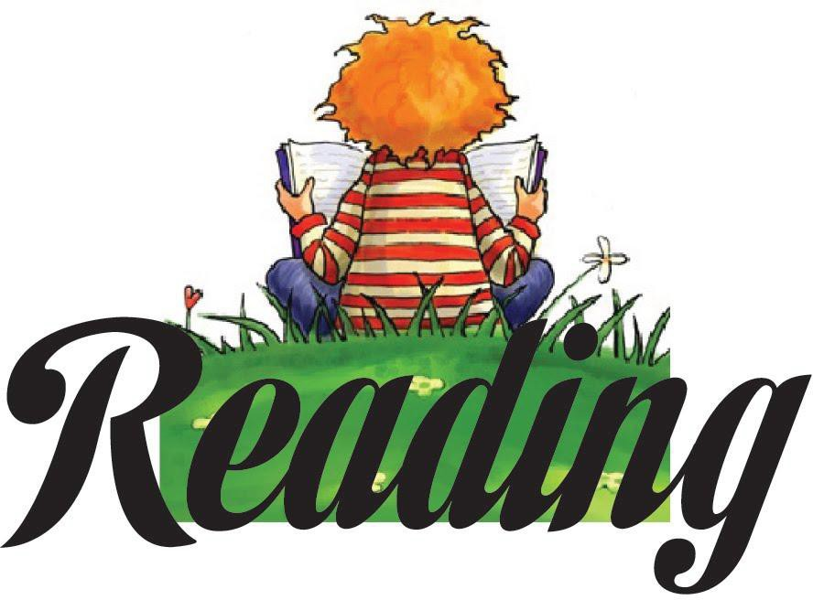
Holy Spirit School Summer 2023
Reading List
Reading is fundamental to learning. It increases your vocabulary, enriches your mind, and stretches your imagination. Recognizing these factors, Holy Spirit School requires all students entering grades K-8 to complete a summer reading program. In addition to these required texts, we have included a list of optional selections and recommended read-aloud books, which we also encourage you to read. The books are available in paperback at local bookstores, libraries, and on-line. This brochure is also located on the School’s website at www.holyspiritflames.org under the “Happening at Holy Spirit ” section on the front page of the website.

ENTERING KINDERGARTEN
Help your child begin the journey into the world of reading with the most enduring classics of children’s literature: nursery rhymes. The rhythm and rhyme of these verses give children important early experience with literature and reading through listening, echo reading, and retelling. Your child should be able to recite the Mother Goose Rhymes at the beginning of the school year.

Read to your child DAILY. When you finish a book ask your child what he/she liked about the book. Encourage discussion about the book with your child. He/she should begin to express answers in complete sentences. Avoid questions with yes/no answers. Rather, ask questions such as ‘why did……go out to the tree?’ and ‘what was your favorite part of the story?’ Help your child develop critical thinking skills by discussing possible endings to a story. Children enjoy imagining what they would have done if they were the main character of a story.

Required reading for Kindergarten:

A Ball for Daisy by Chris Raschka Pancakes for Breakfast by Tomie dePaola
These two books are NO WORD books. Your child can tell you the story using the pictures many times through the summer.

Suggested authors for reading to your child:

Leo Lionni Eric Carle
Dr. Seuss Tomie dePaola
Ezra Jack Keats Mercer Mayer
Arnold Lobel Pat Hutchens
Syd Hoff Bill Martin
Lois Elhert Melanie Watt

**It is recommended that students have a picture Bible of their own for use during the school year.

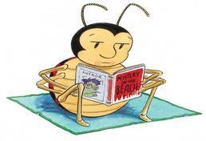

ENTERING 1ST GRADE
Students are encouraged to read daily with adults over the summer. Engage your child in the story by asking questions. Students may also pair read at this stage, where you read a page, then your child reads a page.
Some suggested authors who we will examine during the school year are: Mo Willems
Dr. Seuss David Shannon
Amy Krouse Rosenthal Laura Numeroff
Shel Silverstein Tedd Arnold Drew Daywalt Dav Pikley
Jeff Kinney
Mary Pope Osborne
Chris Van Dusen
Nick Bruel
Barbara Park

By Friday, September 1, 2023 your child will turn in a list of at least ten books they read over the summer.

We also strongly encourage journaling over the summer. It can start as just drawing and then develop into a sentence and a picture. It can be about their day or anything from their imagination!

ENTERING 2ND GRADE
Please choose three books from these series:
ENTERING 2ND GRADE

Mary Pope Osbourne: Magic Treehouse Peggy Parish: Amelia Bedelia
Barbara Park: Junie B. Jones Jeff Brown: Flat Stanley

By Friday, September 1, 2023 the students will turn in a list of the books they have read over the summer.

Other suggested series and authors:

Elisabetter Dami: Geronimo Stilton Ron Roy: A to Z Mysteries
Marc Brown and Stephen Krensky: Arthur Chapter Books Marjorie Weinman Sharmat: Nate the Great series

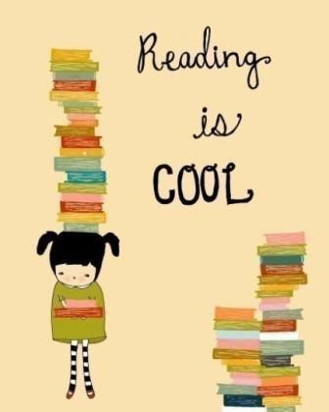

ENTERING 3RD GRADE

REQUIRED:
Beverly Cleary: Muggie Maggie (Lexile 730)
Story of Creation in a Children’s Bible

Please choose two others from this list:
Donald Sobol: Encyclopedia Brown, Boy Detective Series (Lexile 500-700)
Mary Pope Osbourne: Magic Tree House Series (Choose only 1 from this series) (Lexile 300-600) Gertrude Chandler: Boxcar Children Series (Choose only 1 from this series) (Lexile 500-700) Tomie DePaola: 26 Fairmont Ave Series (Lexile 600-700)
Marjorie Sharmat: Nate the Great Series (Lexile 100-400) Betty Birney: The World According to Humphrey (Lexile 670)
Ron Roy: A-Z Mysteries or Calendar Mysteries Series (Lexile 350-600) Megan McDonald: Judy Moody Series (Lexile 390-500)
Beverly Cleary; Any story (Lexile 500-730)
James Dashner: Infinity Ring Series (Lexile 620-910)
C.S. Lewis: The Chronicles of Narnia Series (Lexile 790-970)
Lemony Snicket: A Series of Unfortunate Events Series (Lexile 980-1370)

After reading two of the books from the student’s choice list, the students should create a poster based on one of their books. This project is due on Friday, September 1, 2023.

Poster should be no larger than 14” x 24” and must include the title of the book, the author, a short summary of the story (no more than a paragraph), and an illustration which should include characters and the setting.

SUGGESTED READ ALOUD BOOKS FOR 3RD GRADERS
.
Laura Ingalls Wilder: Little House Series Jack Prelutsky: any book
Shel Silverstein: any book Phyllis Naylor: Shiloh
Roald Dahl: James and the Giant Peach
E.B. White: Stuart Little or Charlotte’s Web
Kate DiCamillo: The Miraculous Journey of Edward Tulane

ENTERING 4TH GRADE

REQUIRED: Judy Blume: Tales of a Fourth Grade Nothing (470L)

This book will be discussed the first week of school and there will be a test.

PROJECT:

For this assignment, you will be reading ONE book, and you have two options to choose from:

- Option 1: "I Survived Series"(590-740L) - This series tells stories of young people surviving real-life events. Choose one book from this series to read and analyze for your project.

- Option 2: Fiction Books - The following list includes five fictional books with varying Lexile levels. Choose one book from this list to read and analyze for your project:
  - "The Boxcar Children" by Gertrude Chandler Warner (580L)
  - "The Lion, the Witch, and the Wardrobe" by C.S. Lewis (940L)
  - "James and the Giant Peach" by Roald Dahl (870L)
  - "Charlotte's Web" by E.B. White (680L)
  - "The Mouse and the Motorcycle" by Beverly Cleary (830L)

Projects to choose from:
- Make a book jacket using construction paper. Write a summary of the story for the inside flap of your book jacket.
- "Using a cardstock (8.5" x 11") on one side, write the title and author of the book and draw a large illustration. On the other side, write a letter to the author telling what you liked about the book."
- Make a series of three pictures to show an event that happened in the beginning, middle and end of the story. Label each picture with a one or two sentence description.
- Make three bookmarks about the book. Show a main character, an important scene and the main idea of the book. Label each picture with one or two sentences.

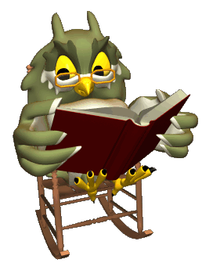
Projects will be due Friday, September 1, 2023.

ENTERING 5TH GRADE

The fifth grade summer reading list is filled with many exciting stories from all types of genres: fantasy, realistic fiction, adventure, historical fiction and biography.

REQUIRED:
Gita Varadarajan and Sarah Weeks: Save Me a Seat (780L)
This book will be discussed the first week of school and there will be a test.

Please choose one from the following list:

Kevin Sands: The Blackthorn Key (630) Raina Telgemeier: Ghosts (300)
Sharon Draper: Stella by Starlight (740L) Carole Estby Dagg; Sweet Home Alaska (870) Ann Rinaldi: The Staircase (590)
R. J. Palacio: Wonder (790L)
Elizabeth Levy: My Life as a Fifth Grade Comedian (520L) Jean Craighead George: My Side of the Mountain (810) Jennifer Nielsen: A Night Divided (810)
Lucy Maud Montgomery: Ann of Green Gables (970)

A Reading Journal Entry should be done for Save Me a Seat and one of your chosen book. The journal entry should be typed and each entry on a separate page. The Journal Entries are due Friday, September 1, 2023.

Format:
Student’s name Date Title of Book Author
Setting of the story (time period and geographic location (at least 1-2 sentences) Favorite Character and 2 reasons why (at least 2 sentences)
Favorite part of book and 3 reasons why (at least 3 sentences)
Things the student would change about the book and 2 reasons why (at least 2 sentences) Character the student would want to have as a friend and 3 reasons why (3 sentences)

ENTERING 6TH GRADE

Required:

Korman, Gordon: Restart

This book will be discussed the first week of school and there will be a test.

Cynthia Lord: Rules (780L)

Please write an interview book report on this book. It is due September 1, 2023.

Please type your book report.

Interview book report: Pretend you are a reporter and you are interviewing one of the main characters. Begin by writing a paragraph describing the character (no less than 5-7 sentences). Write ten questions you would like to ask the character and answer the questions from the character’s point of view. You will tell the plot/story through the questions and answers (answers should be no less than 3-5 sentences).

Choose one of the following books to read:

Laurie Halie Anderson: Chains (780L)
Sharon Creech: The Wanderer (830L)
Shannon Hale: The Princess Academy (890L)
Christopher Paul Curtis: Elijah of Buxton (1070L)
Gary Paulson: Hatchet (1020L)
Gary D. Schmidt: The Wednesday Wars (990L)
E.L. Konigsburg: The View from Saturday (870L)
Lois Lowery: Number the Stars (670L) *IF you read this in 5th grade please choose another book. Rebecca Stead: When You Reach Me (750L)
Corneila Funke: Inkheart (780L)

Write a book report on the chosen book. In the first three paragraphs include information about the setting, main characters, and plot. In the fourth paragraph discuss the problem and resolution of the problem. In the final paragraph write a review of the book. What did you like about the book? Who might enjoy reading this book? Paragraphs should include a minimum of 5-7 sentences.
Due: Friday, September 1, 2023.

ENTERING 7TH GRADE

REQUIRED:

*Hinton, S.E.: The Outsiders (750L)

This book will be discussed the first week of school and there will be a test.

Park, Linda Sue: A Long Walk to Water (720L)

Students should prepare a one-page summary (double-spaced, size 12 font).

L’Engle, Madeleine: A Wrinkle in Time (740L)

Students should prepare a one-page description of a character (double-space, size 12 font).

ADDITIONALLY, Choose one novel (either A Long Walk to Water OR A Wrinkle in Time) and complete one of the following options (Ex: A Wrinkle in Time and Option #1)

Option #1
For this option, draw a timeline of the events that shows the events in the plot and label where the different
events take place. This needs to be done on poster board and should be colorful. For each event labeled, a
picture should be drawn along with a paragraph describing the event.

Option #2
Draw a picture of a character from the novel chosen. Use details in the text to help you imagine what
the character looks like. You can also draw an object that represents the character. With the drawing you are to
include 3 paragraphs that state the following:
- Paragraph with a description of the character along with their role in the novel.
- Paragraph answering: Why did you choose this character? Do they play a major role in the novel? Please be descriptive and do not limit your answer. Get as descriptive as possible.
- A paragraph on where you found the details that inspired your image. Please include page numbers.

Due: Friday, September 1, 2023.

*The Outsiders has long been a classic of middle school classrooms. It tells the story of two rival groups of teenagers in Oklahoma in the 60s, who are divided by class. It has great themes about fitting in, social struggles, standing up for your friends, how our circumstances do or don't shape us, and how economic status shouldn't dictate how we see people.

There is violence in the book as well as mention of alcohol and smoking. These things aren't glorified in any way; the book shows how they damage lives and cause great distress. As they come up, we will discuss them through the lens of our Catholic faith.

If parents would like to choose to not have their child read this selection, please contact the school.

ENTERING 8TH GRADE

Required:

*Golding, William: Lord of the Flies (770L)

This book will be discussed the first week of school and there will be a test.

Lewis, C.S.: The Lion, the Witch, and the Wardrobe (940L)

After reading the novel, students are to write a five paragraph essay, using quotes and concrete examples, exploring how Aslan is similar to Christ.

Lois Lowry: The Giver (760L)

After reading the novel, students are to write a five paragraph essay on one of the following topics: 1. Write an essay that shows how The Giver uses symbolism to show important themes in this novel. 2. Write an essay that shows how The Giver creates an environment of sameness. 3. Write an essay that explains the Community’s reasons for relinquishing color, personal freedoms, and love in the society.

Due: Friday, September 1, 2023
*Lord of the Flies has long been a classic of middle school classrooms. It tells the story of a group of young boys who are alone on a deserted island. They develop rules and a system of organization, but without adults to serve as a civilizing impulse, the children eventually become violent and brutal. Its themes of law and order, civility, and mob mentality are sure to resonate with young readers.
In the book, there is profanity, lurid passages about sex, and statements defamatory to minorities, God, women, and the disabled. These things are not glorified in any way. As they come up, we will discuss them through the lens of our Catholic faith.
If parents would like to choose to not have their child read this selection, please contact the school.
