Third Annual K-8th Grade
Catholic Schools Chess Tournament
Sunday, April 30 from 1PM to 5PM
Check-in begins at 12:30PM

Hosted by

St. Rita School
3801 Russell Road
Alexandria, VA 22305

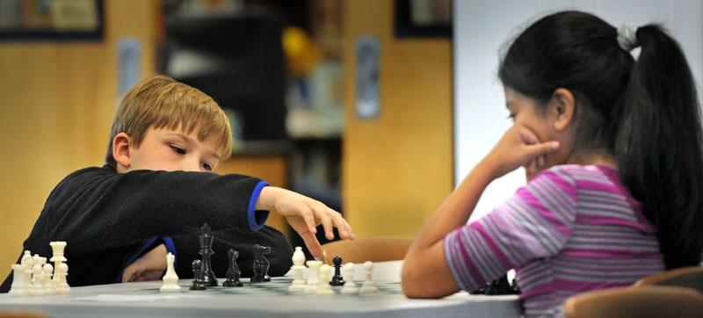

Trophies for top individuals and teams in each division. Participants need not be USCF members or participate in their school’s chess club.

INFORMATION/REGISTRATION: www.stritachess.com
REGISTER BY APRIL 22 TO SAVE $5.00

