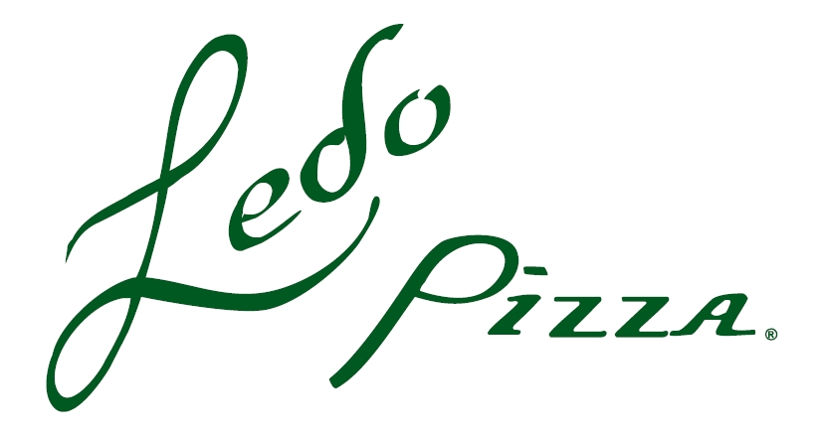

**Bring this flyer with you!**

Enjoy a great family dinner while raising money for   
 Holy Spirit Catholic School PTO

Wednesday November 14, 2018

West Springfield Ledo Pizza

8324 Old Keene Mill Road

West Springfield, Virginia 22152

Holy Spirit Catholic School PTO receives 20% of dine-in sales for each flyer presented! **(Must bring the flyer to get credit)**

Holy Spirit Catholic School PTO also receives 20% of takeout orders when mentioning Holy Spirit! Call ahead for takeout!

**703-451-5336   
  
If any staff or parents order catering the entire week of the fundraiser, our school will get 10% of the check total!**

**Bring a friend and tell your neighbors too! (Just remember to bring a flyer!)  
ALL PROCEEDS GO TO HOLY SPIRIT CATHOLIC SCHOOL PTO**

Holy Spirit PTO Family Night at