2017 BISHOP IRETON CHEER CLINIC
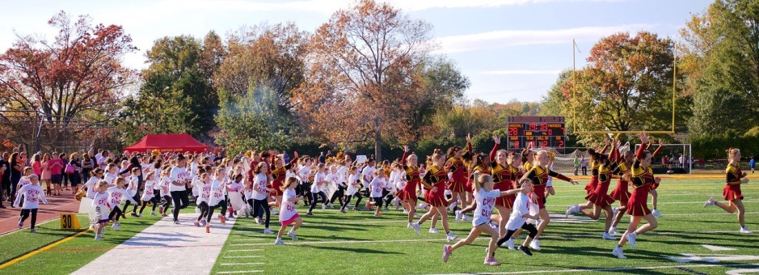
Spend an unforgettable day learning cheerleading and performing with the
2016 & 2017 CCA National Grand Champion Bishop Ireton Cheerleading Team!
WHO: Girls 1st-8th Grade (No experience necessary!)
WHEN: Saturday, October 28 2017, 7:30 am– 3:00 pm
The Clinic concludes with a halftime performance during the Varsity Football Game
starting at 1:00 - Bishop Ireton v. Benedictine College Preparatory School
WHERE: Bishop Ireton High School Gym, 201 Cambridge Road, Alexandria, VA 22314
COST: $50
Registration includes t-shirt, hair bow, lunch & performance at halftime with the Varsity Cheerleaders!! Bring your cameras!! Don’t miss out on this amazing experience!!
Register and pay online at www.bishopireton.org/cheerclinic, or fill out the form below with check made payable to Bishop Ireton High School and write “Cheer Clinic- Anna S.” in the memo line and mail to:
Bishop Ireton Cheer Clinic
201 Cambridge Rd., Alexandria VA 22314
or return to Anna Spirides
Questions? - bicheerclinic@hotmail.com
COME JOIN US FOR THE FUN!

Name____________________________________________________________________________________________

School & Grade____________________________________________________________________________________

Phone # ______________________________________ Parent email ________________________________________

Emergency Contact ______________________________________ Phone # __________________________________

Insurance Company & ID#______________________________________________________________________

Please list any food allergies _____________________________________________________________________
T-shirt Size: YS AS

Thank you,
Anna S :)

